COMP3011 Computer Graphics
Spring 2026
Assessment 2
Report Sheet
Student Name: George Stanway
Student ID: 20541013
Username: psygs6
I agree for my code & report to be published, with my name, to future students as an example (yes/no): yes
Introduction
Please explain why you implemented this scene | Describe your inspirations | Provide a general description of the scene.
I wanted to challenge myself and build a compute shader (based) path tracer optimised enough to run in real time on my rubbish laptop. GPU programming is so interesting and useful (sometimes frustrating), so it was fun building a massive program around it. I learnt a lot and made sure to implement everything in the technical requirements.  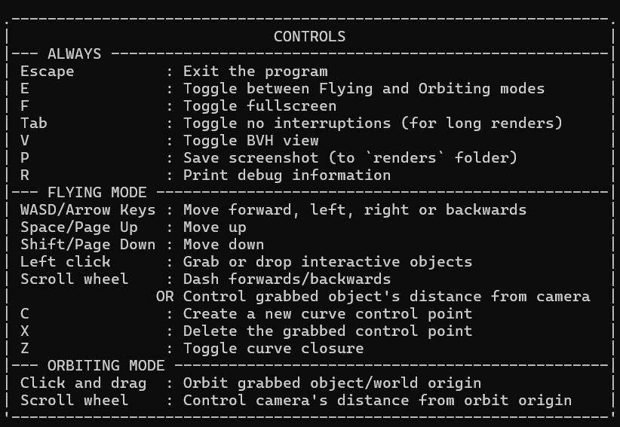  The controls for my program (displayed on startup) | I completed this Learn OpenGL course that introduced me to some raytracing/PBR concepts.  Everything else I added just because I thought it would be fun or mandatory to get the program running fast enough. I did end up going a bit overboard. | The camera starts in a Cornell box containing spheres of different PBR materials (light emitting, glass, mirror, etc…).  Outside there in a massive Sierpinski tetrahedron fractal (procedurally generated) and a high-poly Stanford dragon.  The user can fly around, grab and move or orbit the spheres, create and edit curves, attach spheres to curves, control directional lighting by moving the sun, and much more!  Standing still for a second will start rendering in higher quality.  The visual quality auto-adjusts to hardware speed but I was not expecting the A32 computers to be worse than my laptop (at least for running this program).
TR 2 – 3D Modelling
Object 1 - procedurally generated
Please give a screenshot | reference specific code filename and line number | Description of object
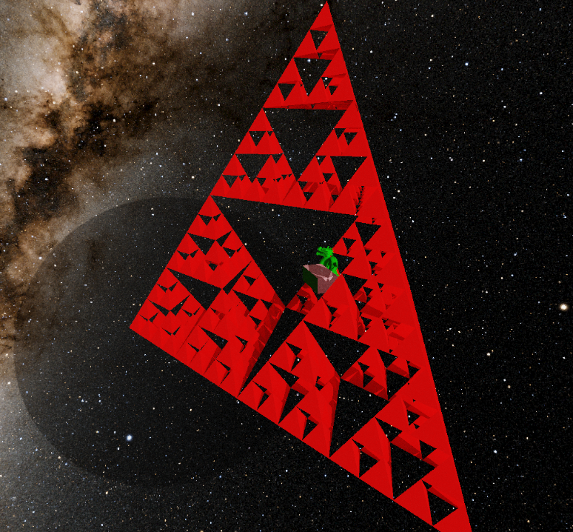 | Model.cpp, BuildSierpinski(),  Lines 128-185 | A massive Sierpinski tetrahedron fractal generated using a recursive function that allows for arbitrary depth.  The number of faces = 4^(depth+1) so at the maximum depth of 7, 65,536 faces are rendered in real time. I limit the depth to speed up loading times (<10s for the whole scene).
Object 2 - OBJ parser
Please give a screenshot | Provide the URL for the OBJ files you submitted | Description of object.
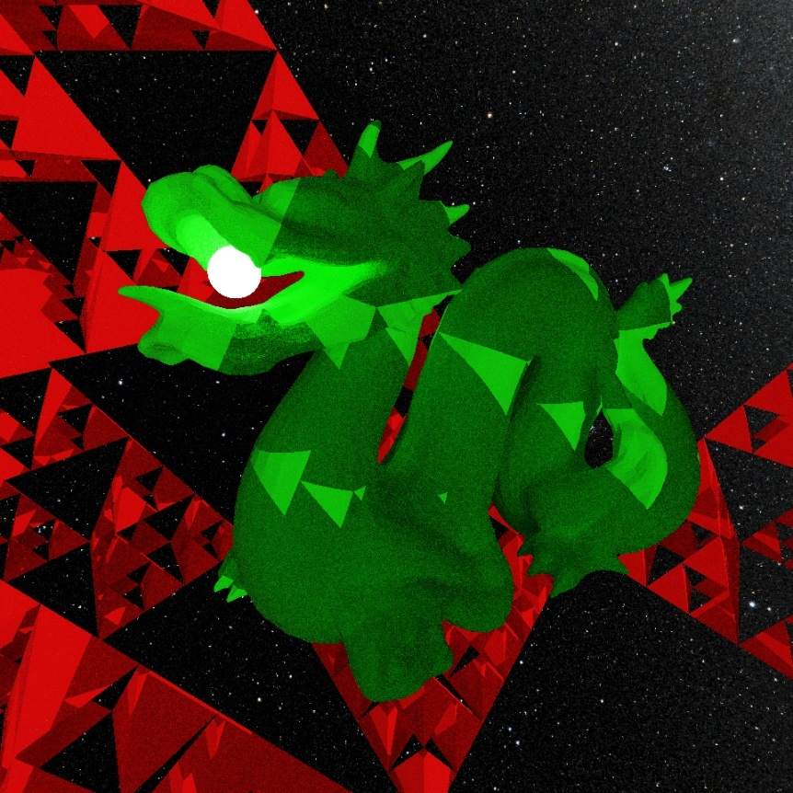  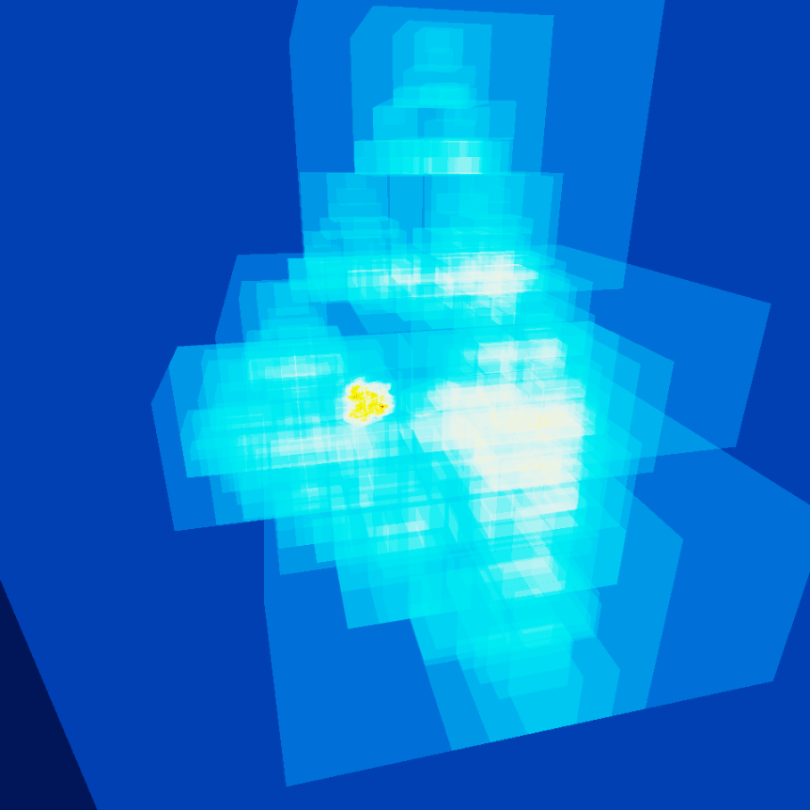 | Stanford Dragon PBR - Download Free 3D model by hackmans (@hackmans) [5d610f8]  (.obj file can be found in res folder) | A lower poly version of the famous Stanford dragon made of 19.3k triangles.  In the first screenshot you can see a quick render (about 10s) that shows both area and directional lighting against the rough green surface.  The second screenshot visualises the BVHs, showing the whole scene. The dragon requires the most AABB tests, so appears hottest.
TR 3 – 3D Transformations
Object 1 - procedurally generated
Please give a screenshot of transformed object | reference specific code filename and line number | Description of transformations
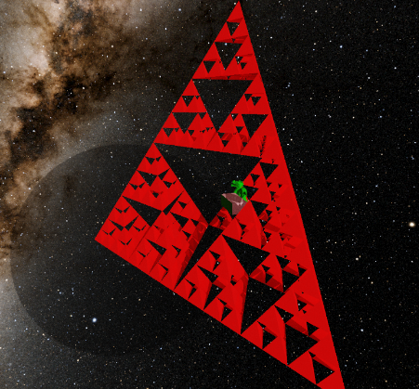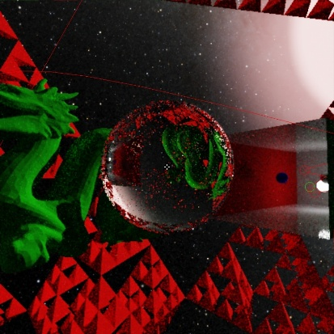 | App.cpp, SetupScene(),  Line 132 ‘fractal->rotate(…);’  Interaction.cpp, Update(), Line 281 ‘heldSphere->translate(diff);’  (ModelInstance.cpp handles transformations) | The Sierpinski tetrahedron is rotated to face in a nicer direction.  Interactable objects (spheres, control points and the sun) are constantly translated whenever moved (by the player or automatically). They are procedurally generated as well.
Object 2 - OBJ parser
Please give a screenshot of transformed object | reference specific code filename and line number | Description of transformations
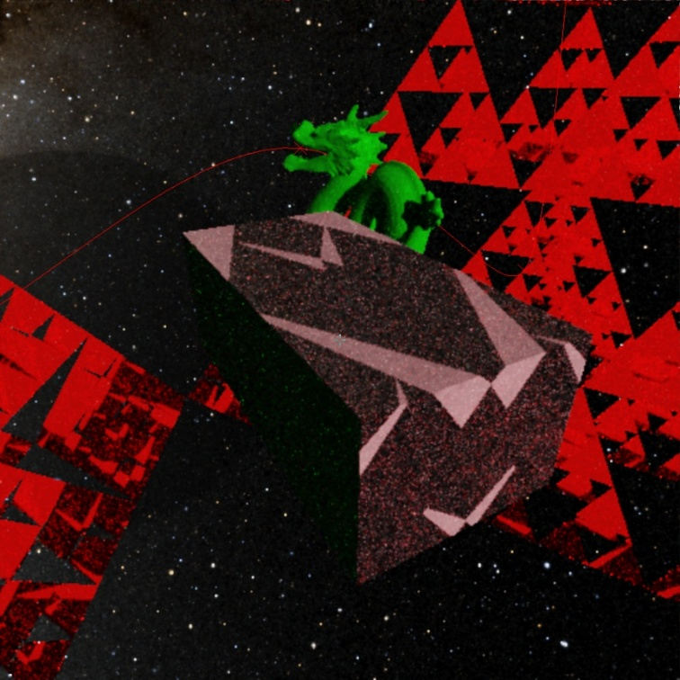 | App.cpp, SetupScene(), Lines 127-129 | The Dragon model has been translated, rotated and scaled after loading to fit well in the scene. The model was four times bigger before being scaled down. The camera is currently looking at the world origin in the first screenshot, showing the dragon’s translation.
TR 3 – Animation
Please give a screenshot of animated object | reference specific code filename and line number | Description of animation
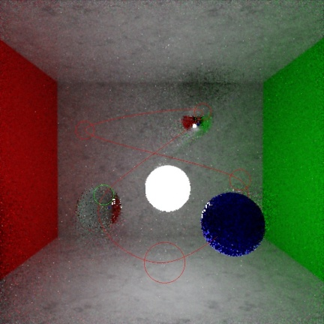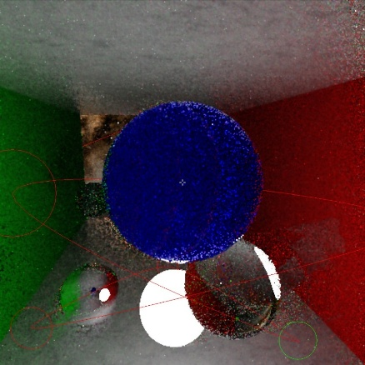 | Curve.cpp,  animateSpheres(),  Specifically line 268 | Spheres can be attached to curves, automatically moving along them. The first screenshot shows 3 spheres on a curve (TAA causes a little ghosting, but not a bug).  When orbiting a sphere that’s following a curve, the camera will follow as well (staying locked to the sphere). The second screenshot shows this perspective.
TR 4 – Camera
Please give a screenshot | reference specific code filename and line number | Description of camera
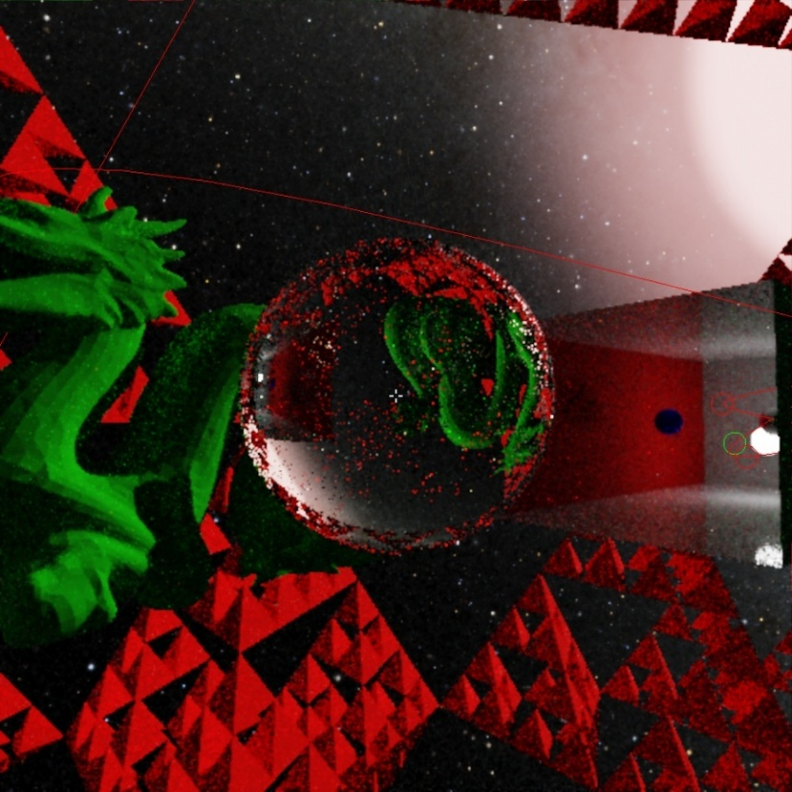 | Camera.cpp, Camera.h  App.cpp UpdateWorld() Line 170 ‘camera->Process(…)’  Interaction.cpp Update() | The camera has 2 modes. Press E to toggle between modes.  The first mode is a free cam with no rotation. WASD or arrow keys to move forward, left, right and backwards. Space to go up, shift to go down. When no object is grabbed, scrolling allows dashing in the direction you are facing. If one is, scrolling moves it further or closer to the camera.  The second mode orbits whatever object is currently grabbed (defaults to the world origin). Click and drag the screen to pan. Scrolling moves the camera further or closer to the orbit origin.
TR 5 – Texture
Object 1 - procedurally generated
Please give a screenshot | reference specific code filename and line number | Description of texture
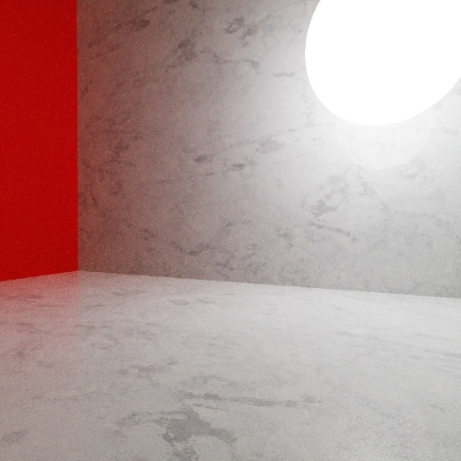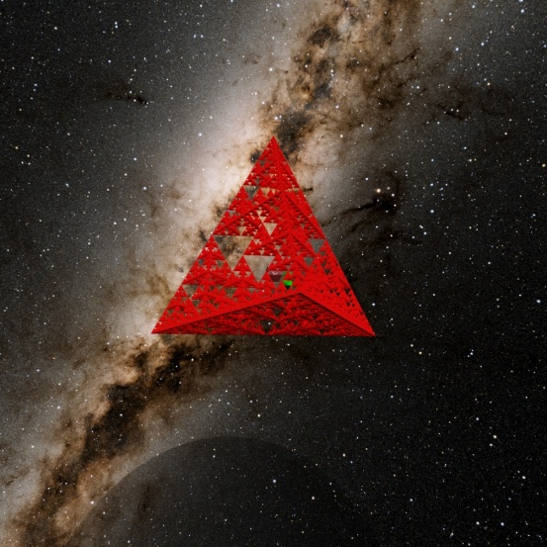 | Texture.cpp, Texture.h  Texture.cpp Texture() Lines 5-43  [Mipmapping on line 34]  Manual compute shader mipmapping:  shader.comp Lines 978-993 | I used a marble texture for albedo and roughness of the white material in my scene, which was used in the procedurally generated Cornell box for the floor, ceiling and back wall, as shown in the first screenshot.  I had to do manual mipmapping in my main compute shader to use the mipmaps I generated in code.  A 4k texture from NASA of the Milky way galaxy (as a raw texture) was loaded and used for the skybox (second screenshot). Sampling is done manually.  I also loaded a blue noise texture (as a raw texture) for a more uniform randomness distribution in the main compute shader.
TR 6 – Lighting
Object 1 - procedurally generated
Please give a screenshot | reference specific code filename and line number | Description of lights on object
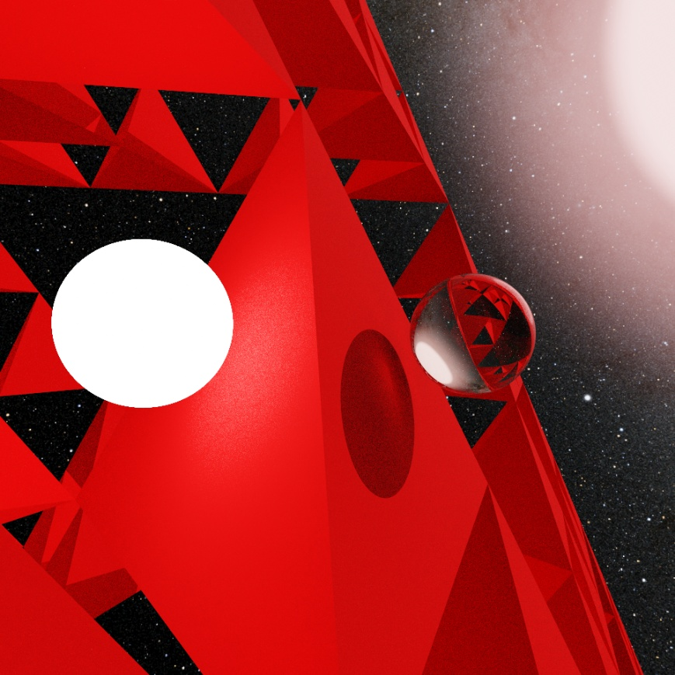  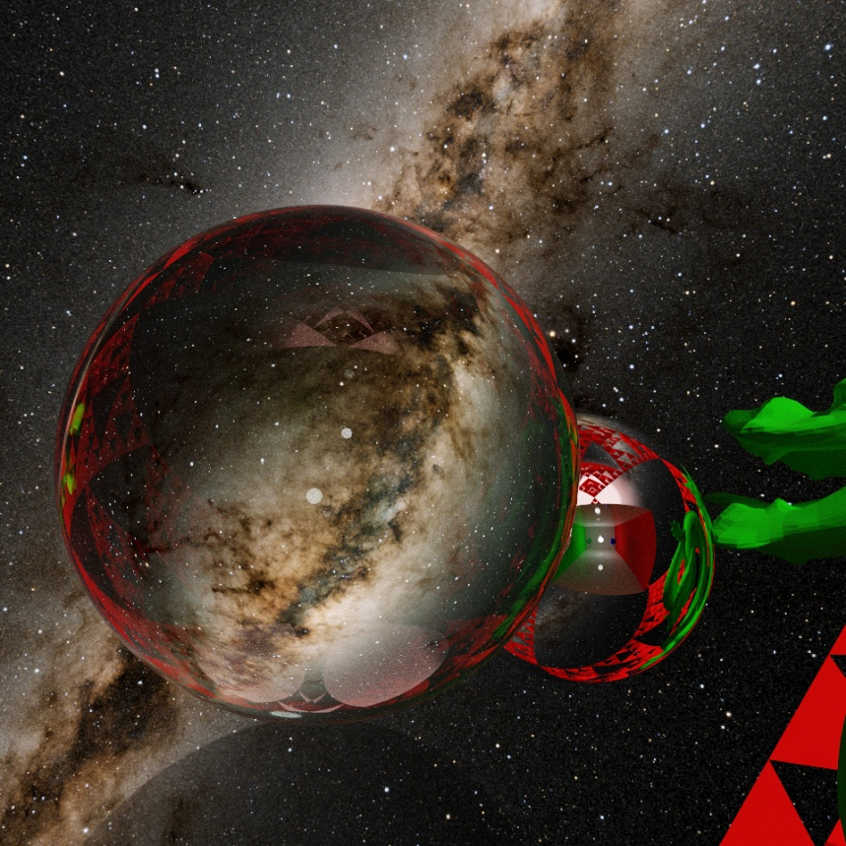 | The ‘shader.comp’ compute shader does all the heavy lifting for lighting and shadows.  These functions are notable:  pathtrace() simulates rays bouncing around the scene.  computeDirectLighting() and computeSunLighting() find the direct contribution from the light sphere or sun respectively at a point on a surface, taking into account the material properties of the surface (uses NEE).  sampleDiffuse/Specular/  Transparent() find how much energy/colour is lost at a collision and what direction the ray should bounce in (uses BSDF sampling). This is different for rough, shiny or transparent materials.  Rays with low energy that don’t hit a light source are killed (russian roulette).  missColour(): Rays that miss geometry sample the skybox texture for their colour | The first screenshot shows off the 2 types of lighting in my project, area and directional. The light sphere is lighting up faces of the fractal that would be in shadow, and the sun is casting light onto the glass sphere, forming a shadow with a focused highlight.  Spotlights/torches would be possible as well, if I put an area light behind a pinhole.  The second screenshot shows how light realistically reflects and refracts when hitting materials.
Object 2 - OBJ parser
Please give a screenshot | reference specific code filename and line number | Description of lights on object
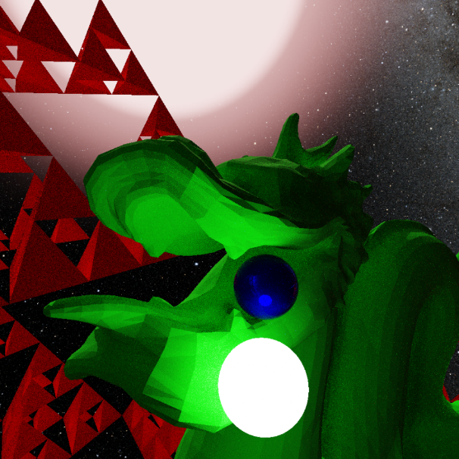 | All the same code from above applies (all faces are equal to the compute shader) | An area light sphere is lighting the dragon’s head from below.  Directional light from the sun casts a slightly pink light across the dragon’s head and back.
TR 7 - Shadow
Object 1 - procedurally generated
Please give a screenshot | reference specific code filename and line number | Description of shadow on object
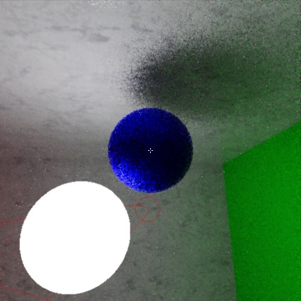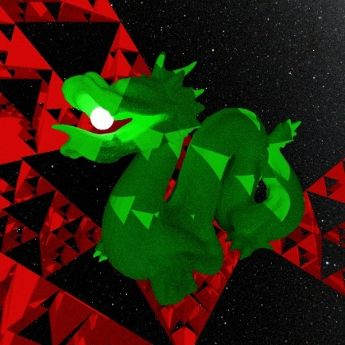 | shader.comp has specialised versions of collision/traversal functions for fast occlusion testing:  intersectTriangleShadow(),  intersectSphereShadow(),  traceShadow()  The lighting functions from above are vital for shadows as well. | Dynamic lighting and shadows come for free in a path tracer (which is one of the reasons I made one).  I’ve optimised the program enough to allow for real-time shadows. The first screenshot shows this.  The second screenshot shows the fractal (procedurally generated) casting shadows on the dragon by blocking the sun.
Object 2 - OBJ parser
Please give a screenshot | reference specific code filename and line number | Description of shadow on object
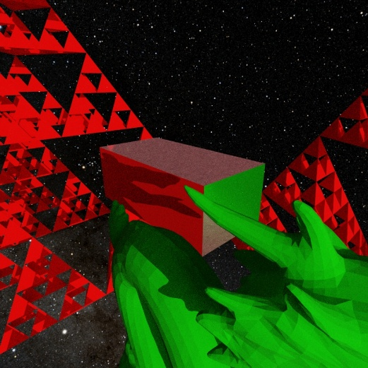 | The same code from above applies. | The screenshot shows the dragon blocking the sun and casting a shadow on the Cornell box.
TR 8 - Interactive object
Please give a screenshot | reference specific code filename and line number | Description of interactive object
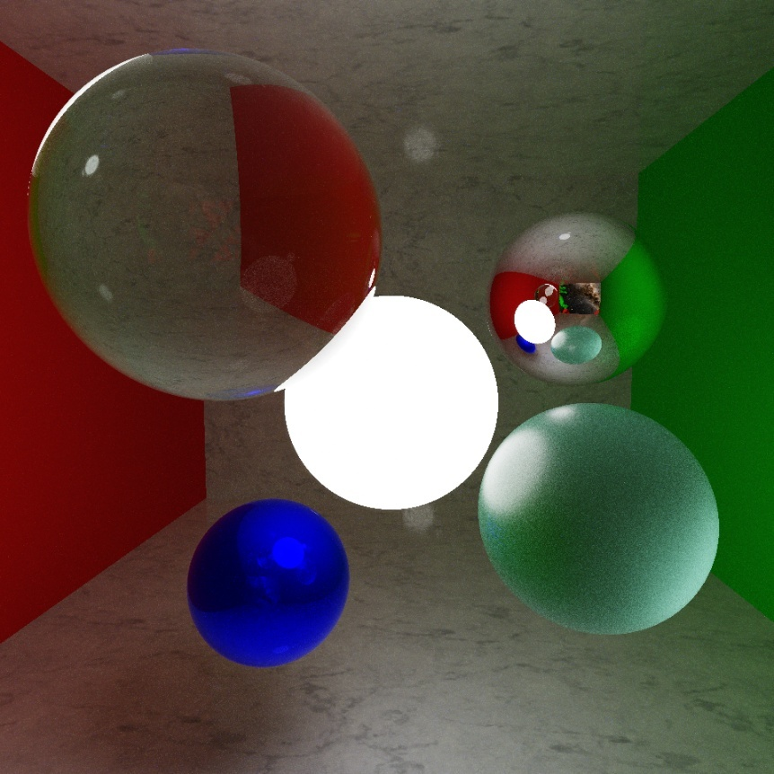  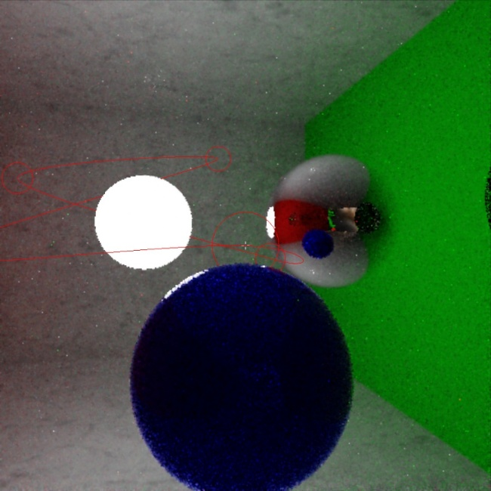 | Interaction.cpp, Interaction.h,  OnLeftClick(): Raycast (on the CPU) to find grabbable objects [then Grab() or Drop()]  OnScroll(): If holding an object, move it closer/further, otherwise dash forward. | The spheres or curve control points can be grabbed and dropped with left click and moved with the mouse. Scrolling pushes them further or pulls them closer to you.  The first screenshot is a longer render of the spheres within the Cornell box. I moved them into this arrangement before letting this image converge.  The second screenshot shows the user grabbing and moving one of the curve control points. The curve updates live when they are moved.
TR 9 – Curves
Please give a screenshot | reference specific code filename and line number | Description of curves
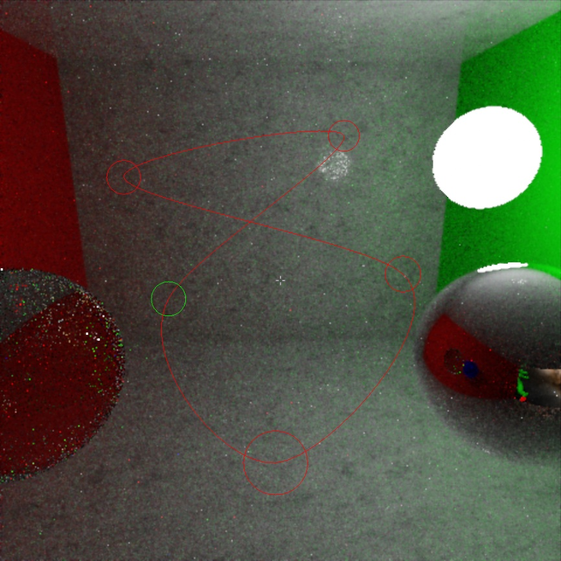  The small, editable curve in the Cornell room.  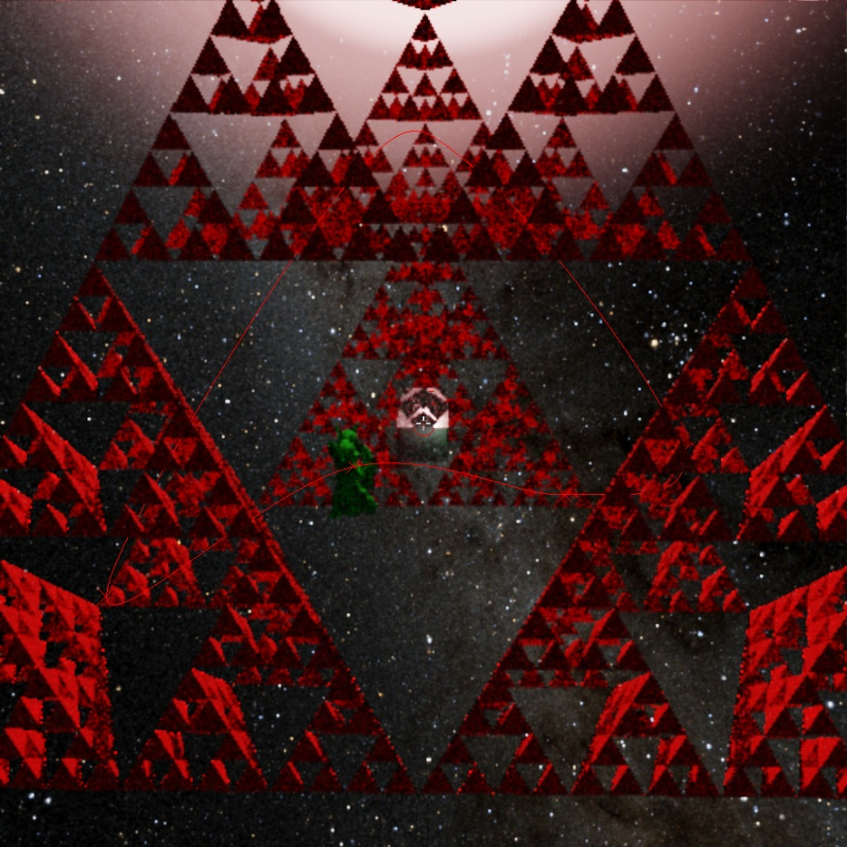  The bigger, un-editable curve that loops around the scene | Curve.cpp, Curve.h  bezier.vert, bezier.frag  update(…): Builds the curve  draw(…): Draws the curve and control points  animateSpheres(…): Moves spheres currently attached to a curve along it | I implemented Catmull-Rom splines that can be built and edited live, updating in real time. Each segment of the curve is converted to a cubic Bezier curve and built using De Casteljau's algorithm, allowing for easy manual path construction and C1 continuity (and hopefully the marks for this section).  I initially implemented arbitrary degree Bezier curves but found that constructing paths by hand was almost impossible (moving any control point affects the whole curve).  I found this paper which explained how to convert between Catmull-Rom and Bezier, which is quite simple and elegant.  Every time the curve is edited (control points are moved/added/deleted) the whole curve is rebuilt, with resolved points and the distances between them being cached for drawing/searching.  Curves are rendered on top of the graphics as a line strip using a vertex/fragment shader pair (bezier.vert/frag). Curves are only visible when moving. This is how I have demonstrated my knowledge of the rasterization pipeline.
TR 10 – Transparency
Please give a screenshot | reference specific code filename and line number | Description of transparency
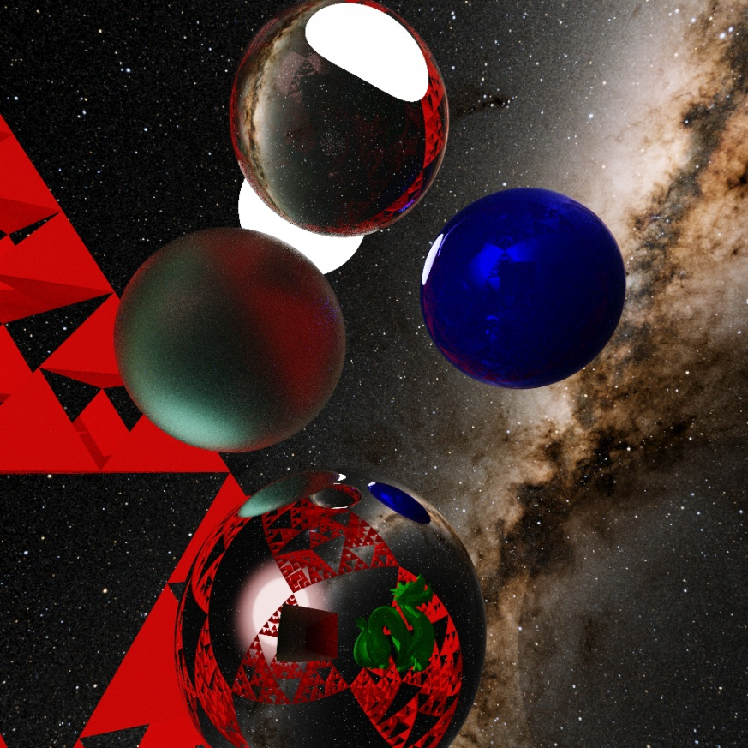  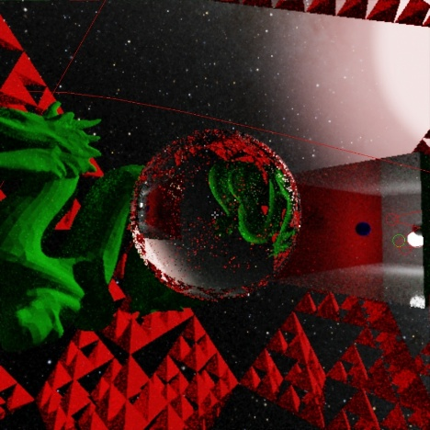 | shader.comp lines 1088-1092 and sampleTransparent() | The first screenshot shows off every aspect of transparency.  The glass sphere (top) is refracting the environment. Total Internal Reflection is happening so you can see the pink sunlight.  The sea-glass sphere (left) demonstrates the same principles, but with physically based rendering techniques.  The mirror sphere (bottom) is opaque but perfectly reflective.  Transparency works in real-time, so you can grab the glass sphere and hold it to the camera to see the world upside down, like a lens (second screenshot).
R&D
Please provide details of any research and development you conducted, as additional techniques not in the lecture notes.
Please give a screenshot | reference specific code filename and line number | Description of Research including websites, articles, references, etc.
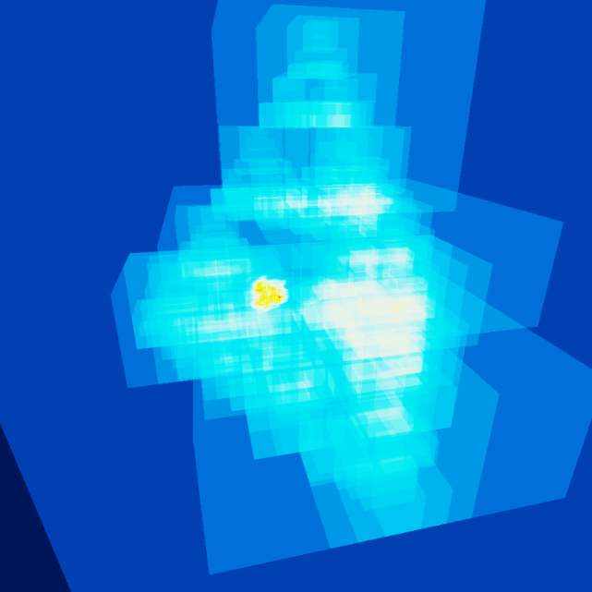  Heat-map BVH view (shader.comp traceHeatmap()) | BVH.cpp, BVH.h  GPUNodes.h, AABB.h  The main compute shader:  shader.comp  Renderer.cpp, lines 181-245  shader.comp lines 727-814 (all the shadow ray calls)  shader.comp lines 694-814 (at the ends of functions)  The TAA/rendering compute shader: taa.comp  The postprocessing shaders: display.frag (and shader.vert) | These are the major features I’ve implemented:  BLAS/TLAS on the GPU  S1 (great paper), S2  3 SSBOs (+1 for materials) in shader.comp store the acceleration structure that allows for fast ray-geometry collision finding. Without this the speed I have would’ve been impossible.  The Nodes buffer stores compressed, flattened 4-wide BVHs (built on the CPU).  All the BLAS BVHs come first in this buffer, each one storing a loaded Model (fractal, dragon, etc…) as a tree of bounding boxes of triangles, which are stored in the Triangles buffer. All this data is static (since triangles are local to the Model’s origin).  Right at the end is the tiny TLAS BVH, which stores the instances of Models. Each Instance in the Instances buffer stores an index to the BVH for its model, and the instance’s transformation matrix. This data is dynamic and must be rebuilt when instances move.  In traceScene(), traceShadow() and traceHeatmap() I use a stack to traverse the Nodes buffer, starting from the TLAS root. If the ray being queried hits an Instance, it’s transformed into the Model’s local space, before traversing the BLAS and hopefully hitting geometry.  Dynamic Quality  I designed a state-based heuristic to edit parameters in response to the FPS, to keep it stable.  [Renderer::DynamicQuality()]  Next Event Estimation (NEE)  I made optimised collision functions for occlusion checking (firing shadow rays) so I can sample lights directly to converge faster. [traceShadow(), intersectTriangleShadow(), intersectSphereShadow()]  Multiple Importance Sampling  NEE directly sampling light sources is not representative of the distribution of light on a point. MIS lets you get away with it by calculating the probability of the event and dividing by it. This Monte-Carlo integration process allows for much faster convergence when samples are accumulated.  Russian Roulette  Kill low energy rays that aren’t worth more bounce calculations. [bottom of shader.comp pathtrace()]  Temporal Anti-Aliasing (TAA)  My second compute shader stage (taa.comp) either builds a running average of samples (when rendering/standing still) or implements TAA (when moving). The world position of each pixel is calculated from distance from camera (stored in w/a channel) and camera position/angle. Then I work out where that pixel would have been in the history (last) frame by using the last camera PV matrix (temporal reprojection). This history colour is rejected if invalid, or mixed with the current sample, allowing for smear-free movement.  Postprocessing shader  ACES Narkowicz fit tone mapping, exposure and gamma correction, interleaved gradient noise dithering and a helpful crosshair for grabbing objects.

